Kay Ahlheim

Full post with image and caption… no formatting yet 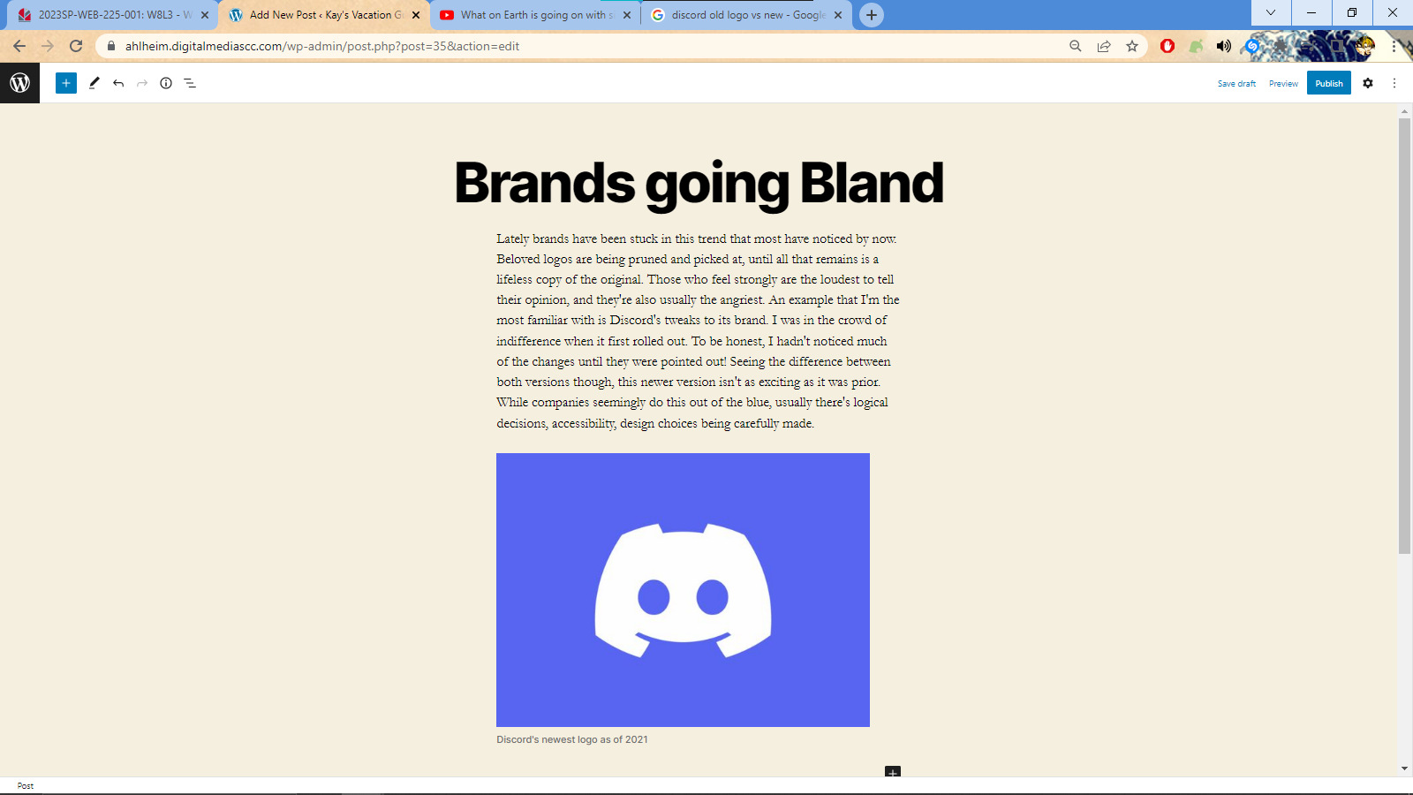
Aligned Left
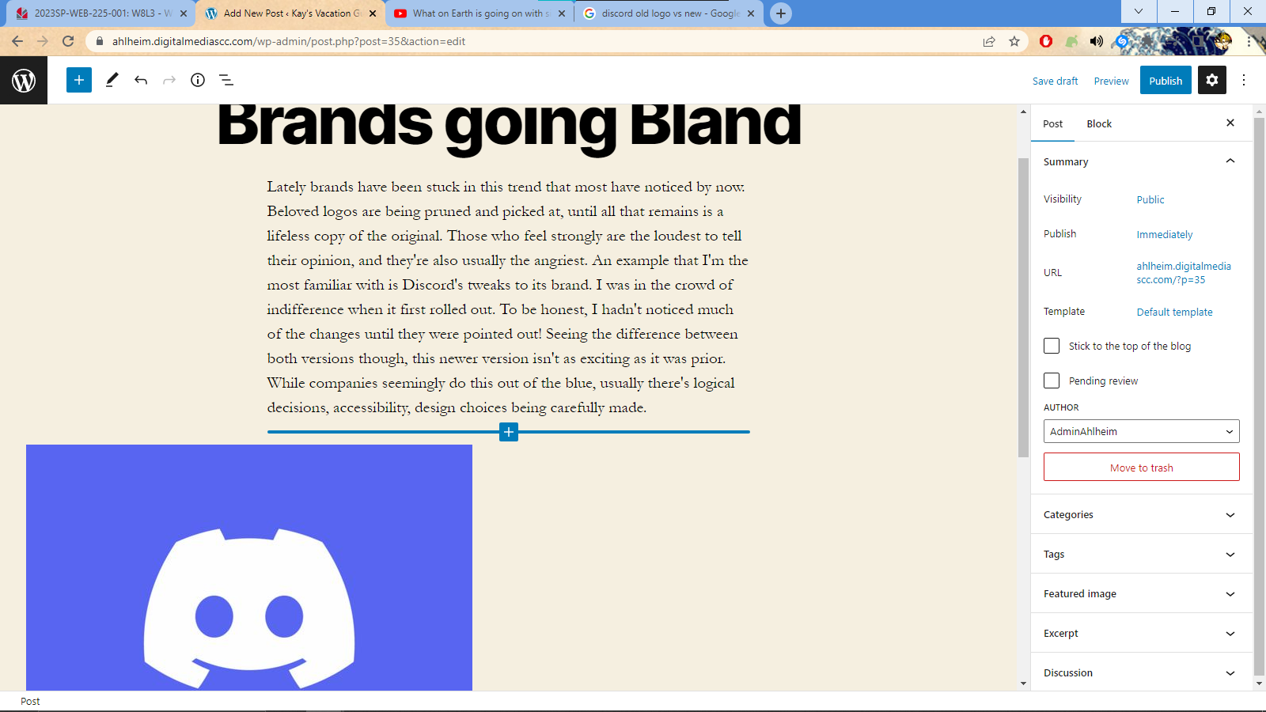
Aligned right
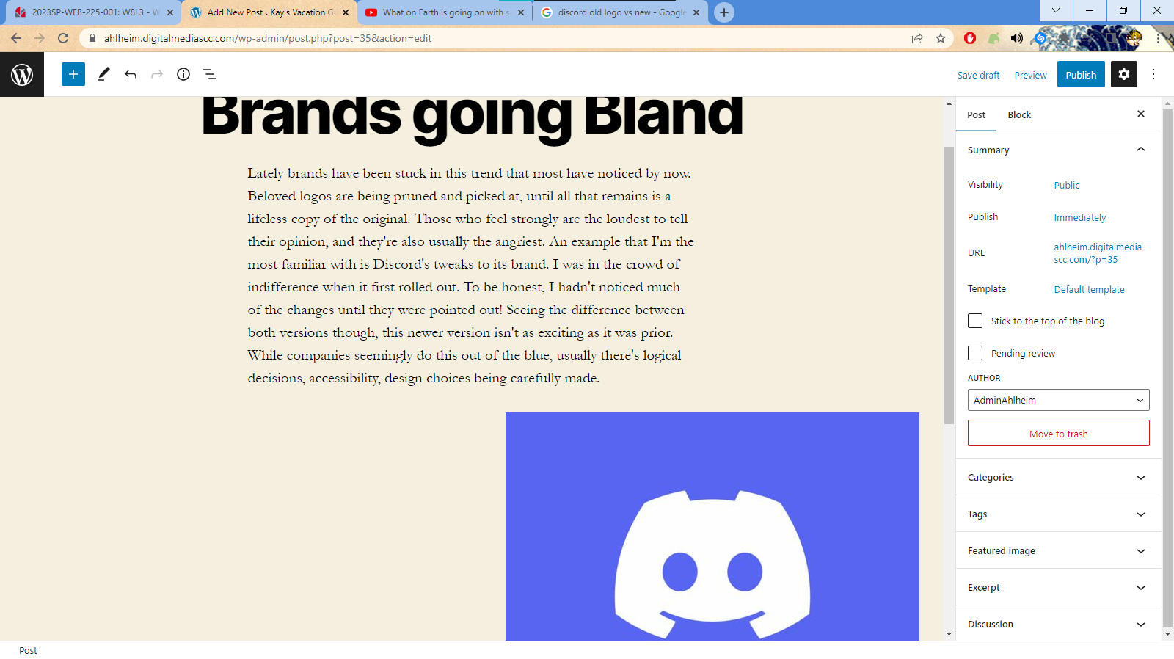

Aligned center
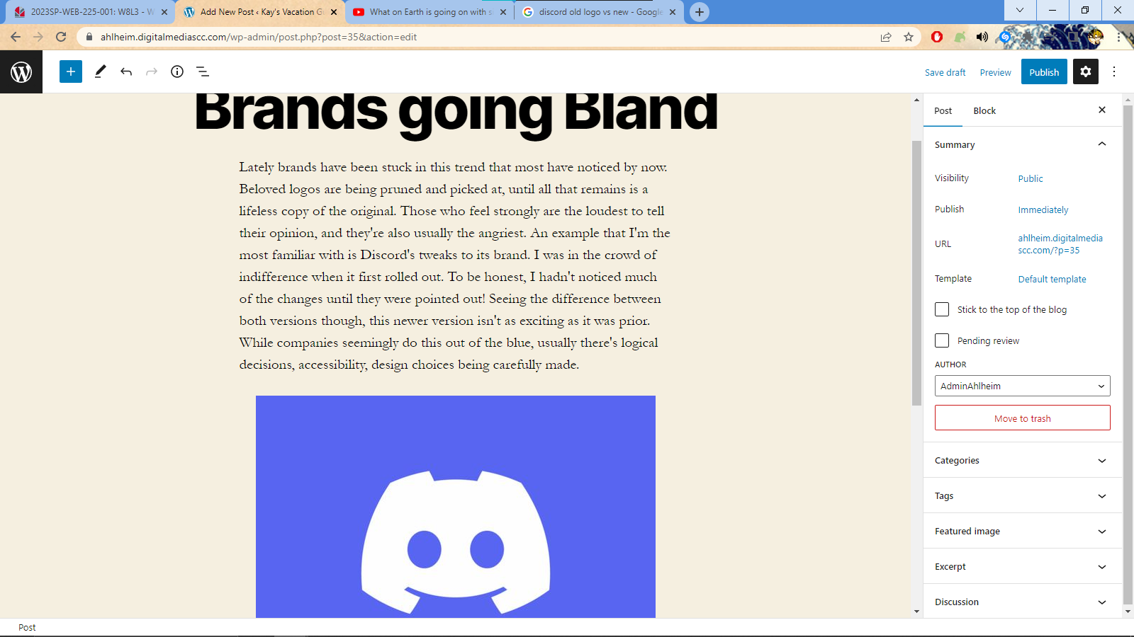

Wide Width
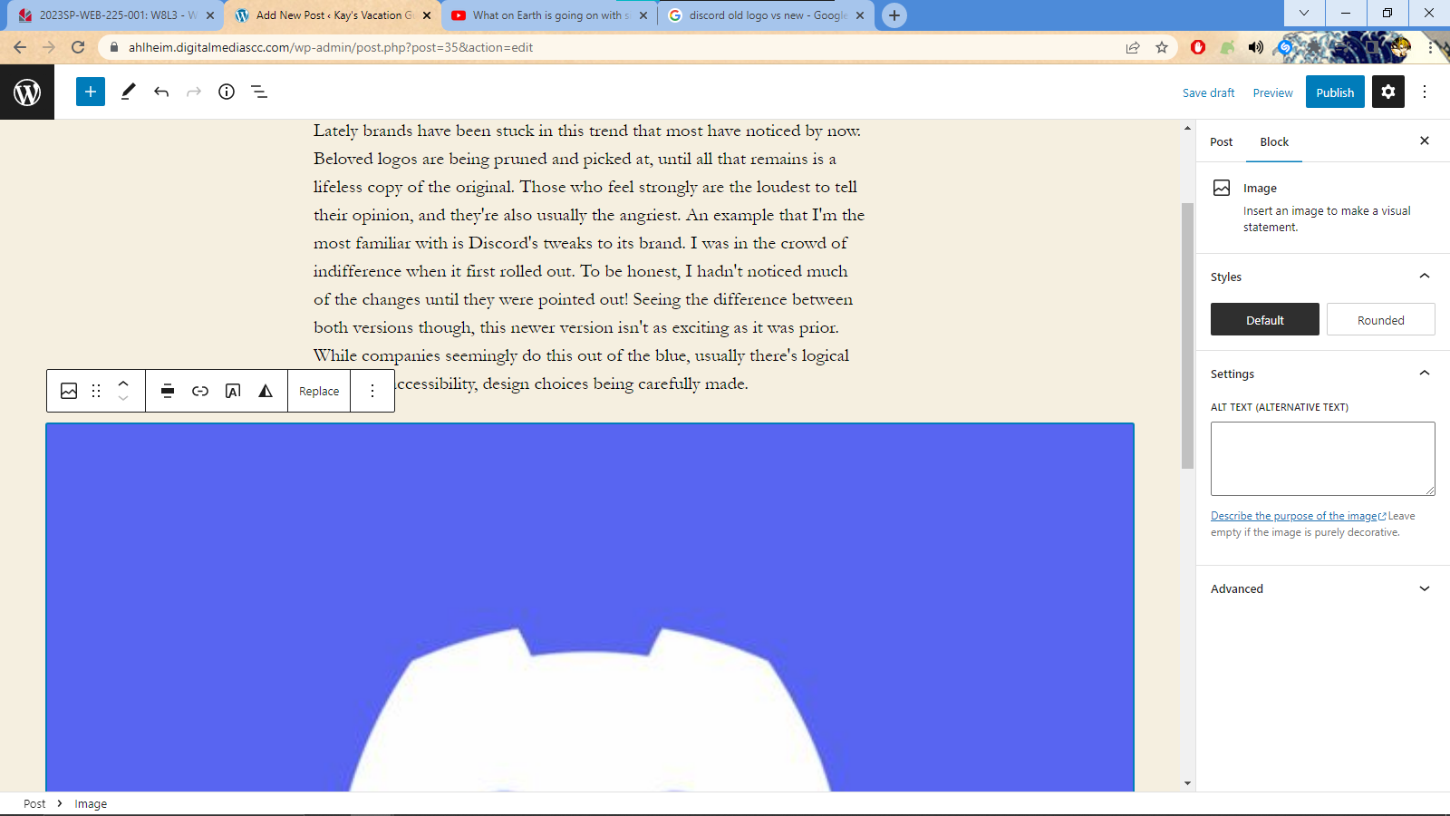
Full width
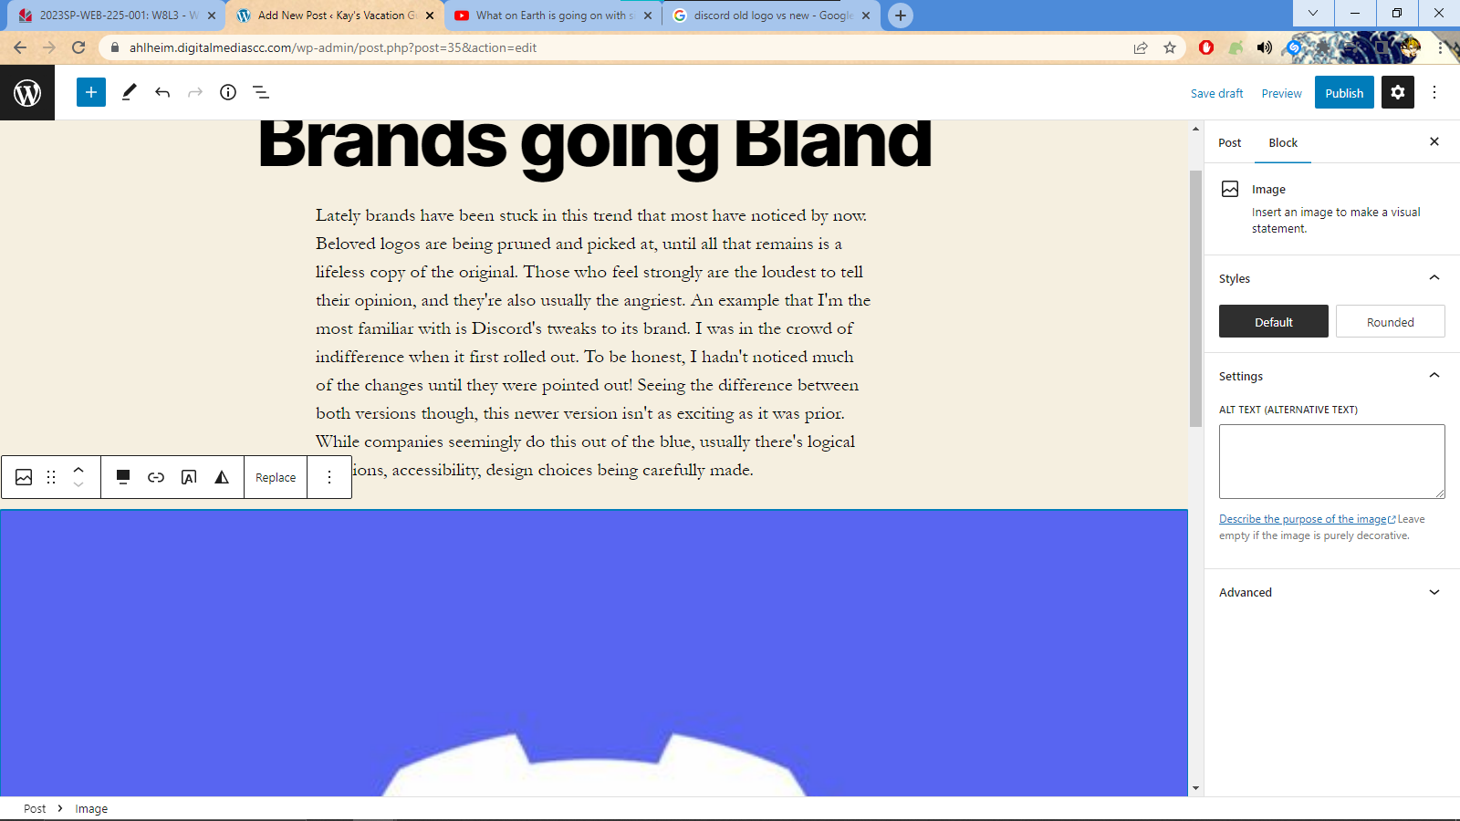

Image URL I used in the second post:
https://www.underconsideration.com/brandnew/wp/wp-content/uploads/2020/12/pringles_logo_before_after.png

Media and Text
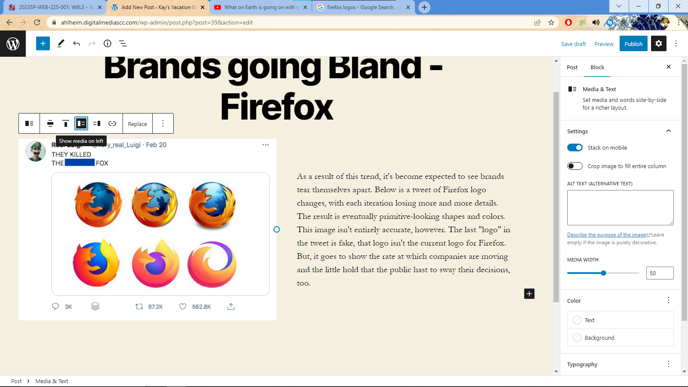
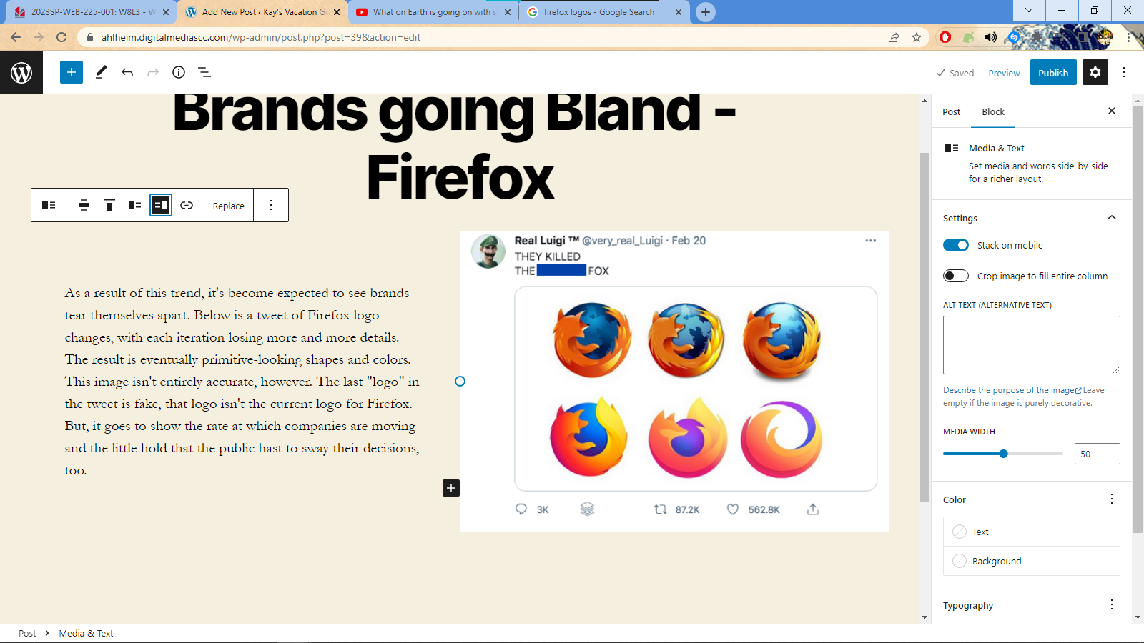
Playing with image size (my Media and Text block was equal to begin with, so I played around and made the image smaller)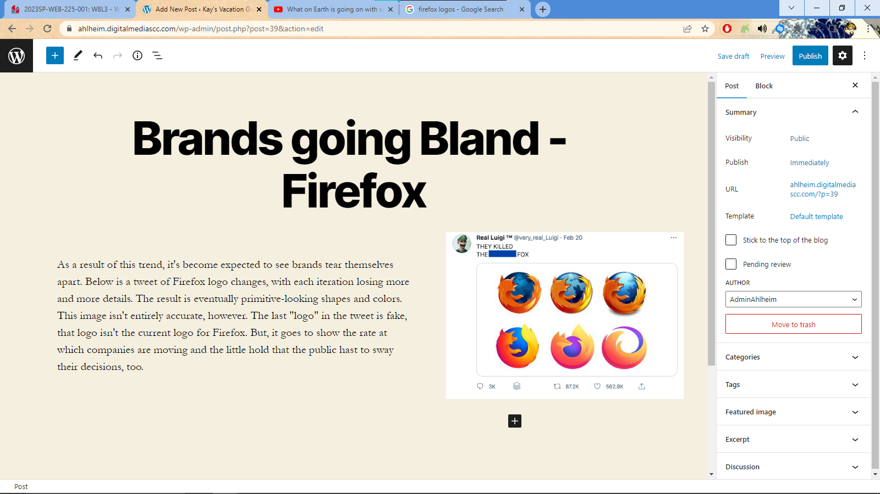
Bottom and top aligned text
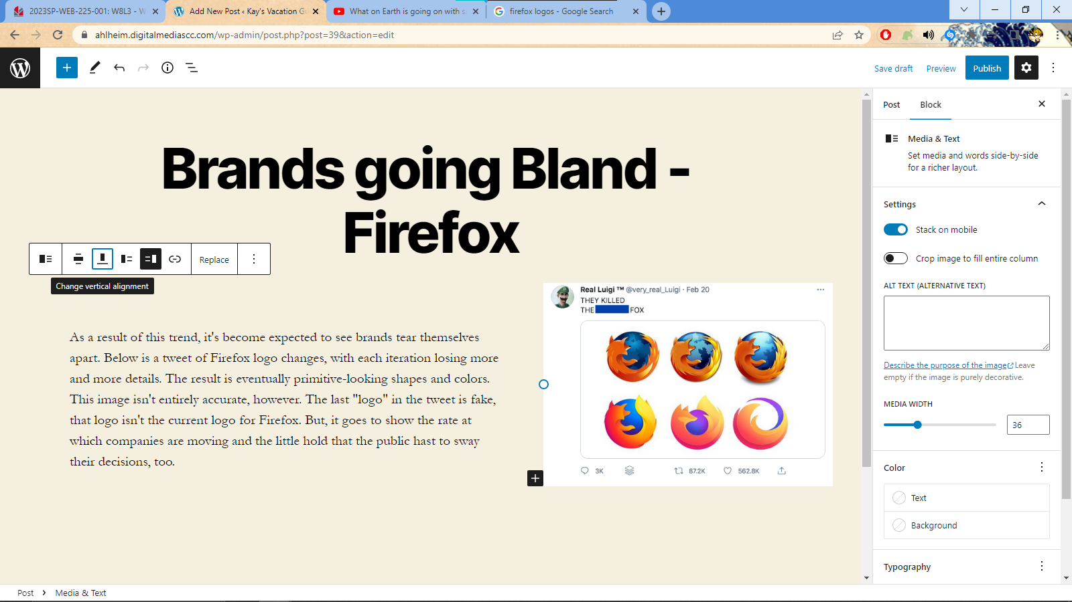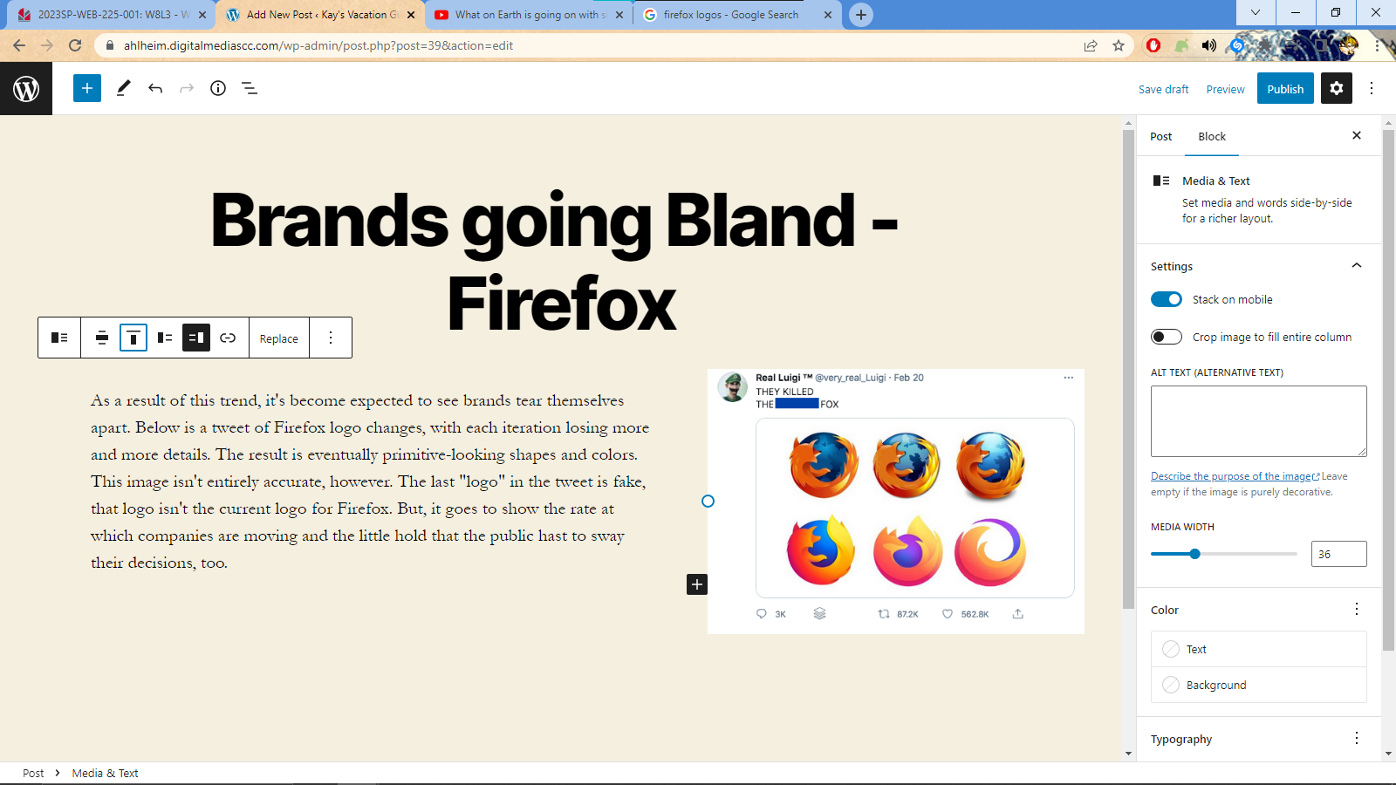

Inline Image – At first, throwing an image inline looks clunky. The width didn’t match with my text, but it was easy enough to change it to do so.
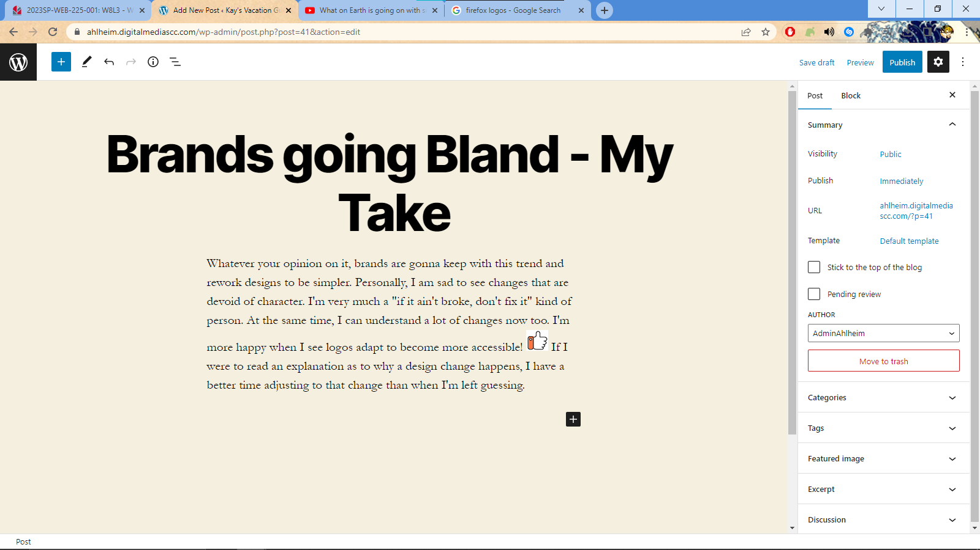

Gallery Block… couldn’t find what you meant by themes for it
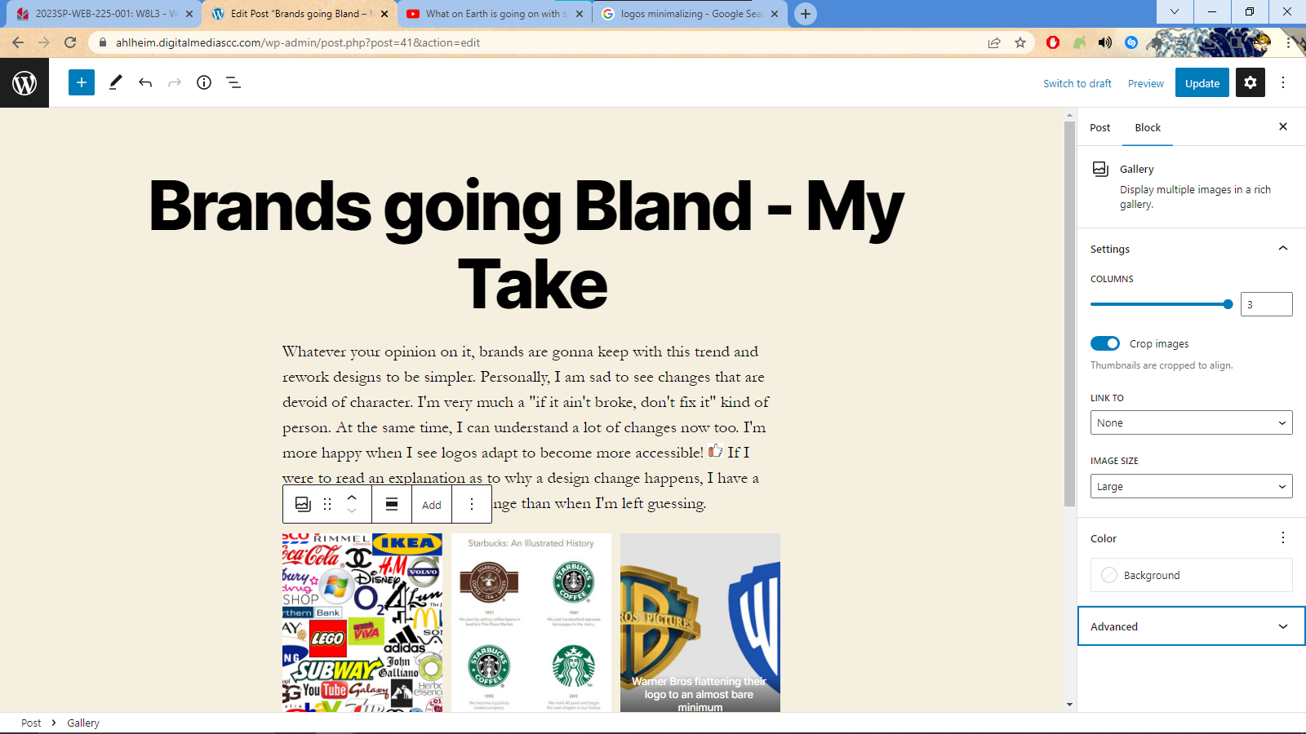

Gallery layout
